**Client-Side App Rubric** <https://github.com/denisecase/pbl-lifeline-links>

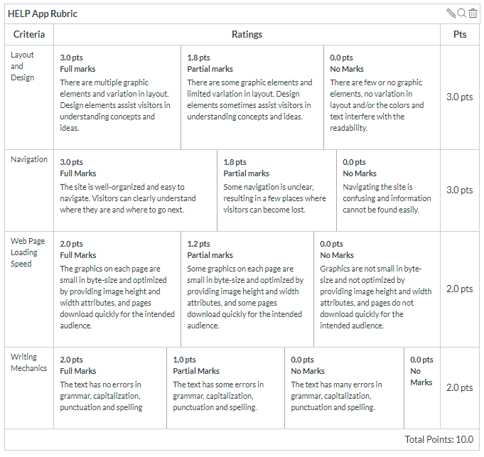

**Team reviewed: 02-06**

**Link to the web site:** <https://anil-bomma.github.io/pbl-help-app/index.html>

**Layout and Design**

Score: 1.8

Comments: The about page and the contact page the information on the picture is not clear, it’s hard to read, especially for older cliental. The about page is just a block of so much information that no one is going to want to sit down and read, try breaking up the information or using bullet points to simplify the information. The contact information is barely visible. The footer is very large with lots of white space, and we recommend centering the information in a grid so that it looks less awkward.

**Navigation**

Score: 3

Comments: Nav bar is understandable however it is hard to see until you scroll down the page.

**Loading Speed:**

Score: Comments: We did not have any issues with loading.

**Writing Mechanics:**

Score: 1

Comments: Main page is fine but the other pages are hard to see and very wordy. Try to simplifying the information

**General remarks: Overall we like the landing page and if the improvements are made to the other pages that we listed above this will be a really good website.**

**Review performed by: Group 3**

**Date and time performed: 12/5/2019**